LAB NO: 1

LAB AIM: To study and apply Data Preprocessing techniques on given dataset. Prepare a titanic dataset for training with machine learning algorithm by applying suitable data preprocessing techniques

DATASET AND RESOURCES : Titanic Dataset from Kaggle and Python/Jupyter Notebook

DATE OF PERFORMANCE:17 -07 -2026

GITHUB REPO LINK :
https://github.com/Prabhkirat-Singh-Marwah/ML-PRACTICALS/tree/main/Practical-01

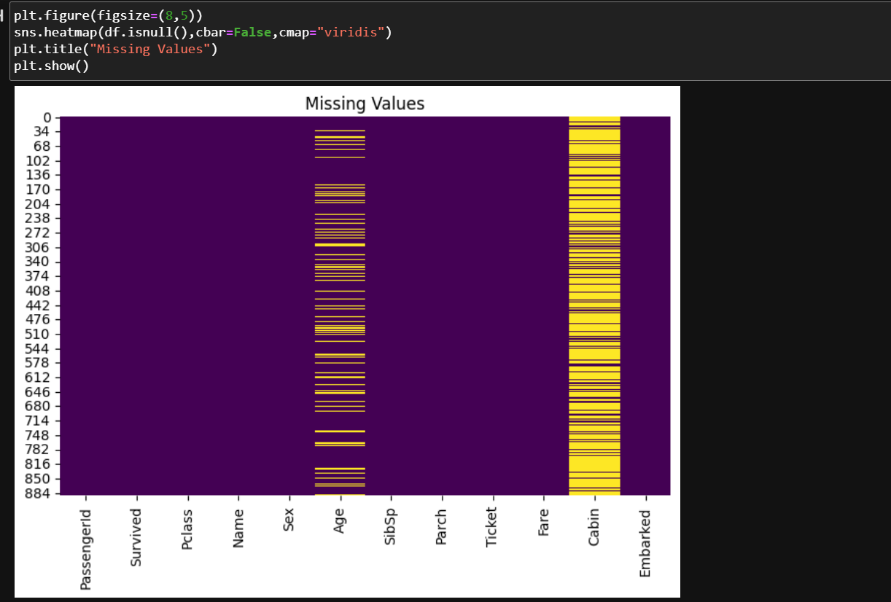
This command prints a heatmap and displays the missing values , which are mainly In age and cabin

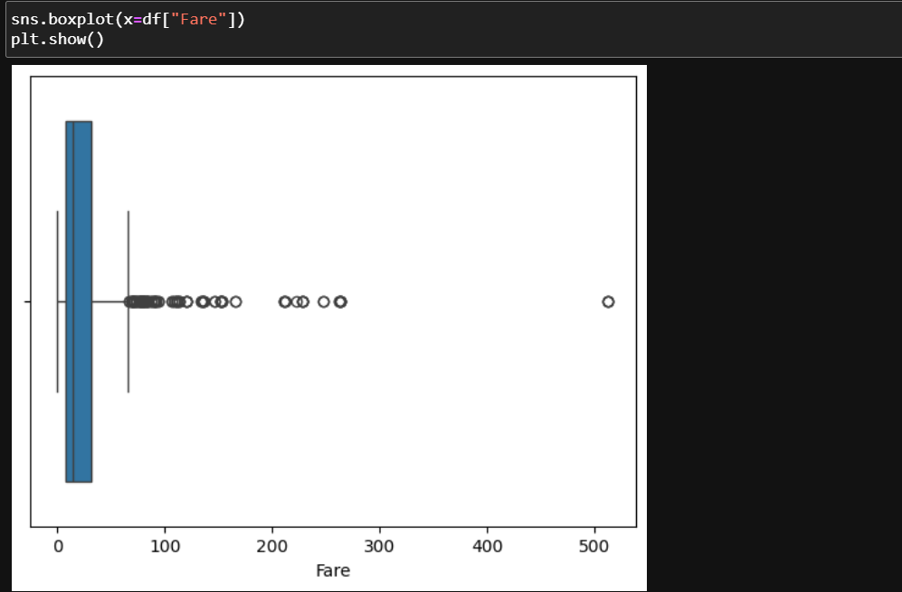
This command prints a boxplot to identify the outliers and the spread of data
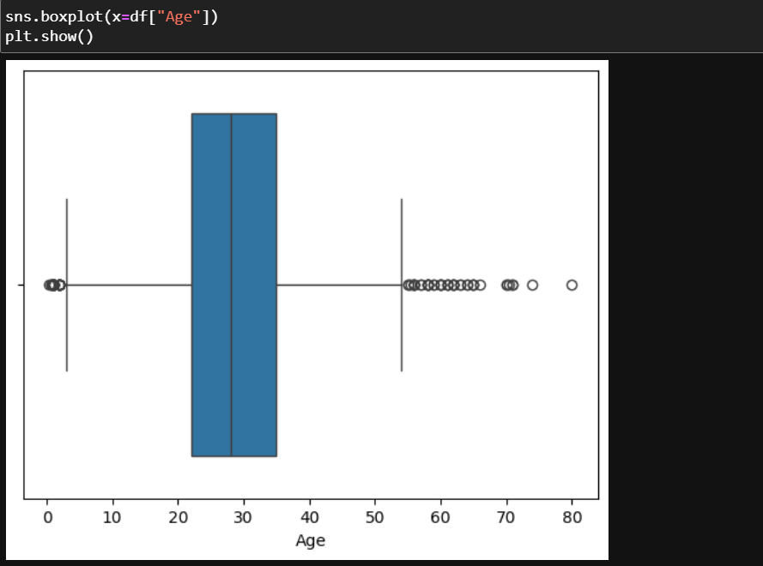
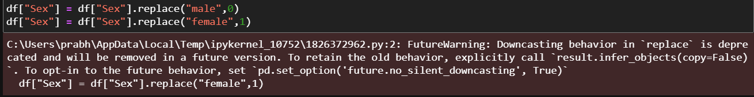
This command changes assigns male to 0 and female to 1so the values become numeric 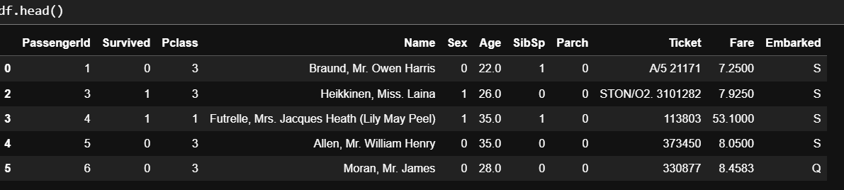
Head() prints first 5 rows of the dataset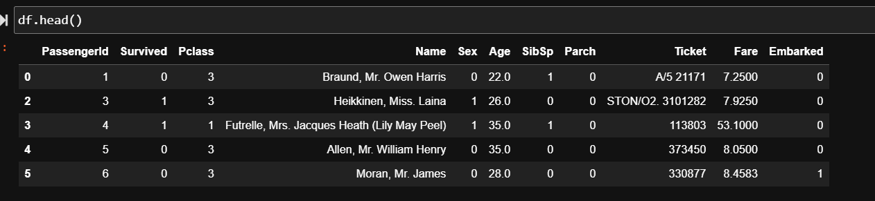 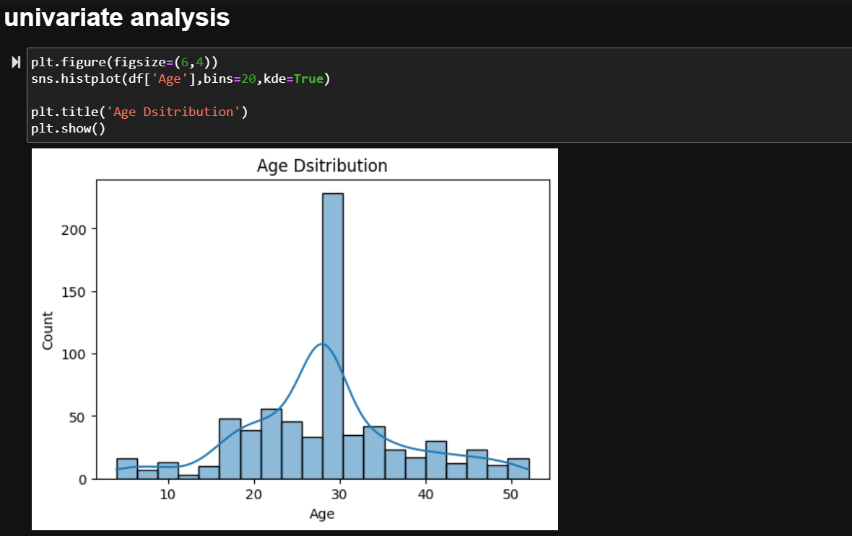
Univariate analysis means it analysis data based on only one variable.this command sprints a histogram to show age graph of passengers 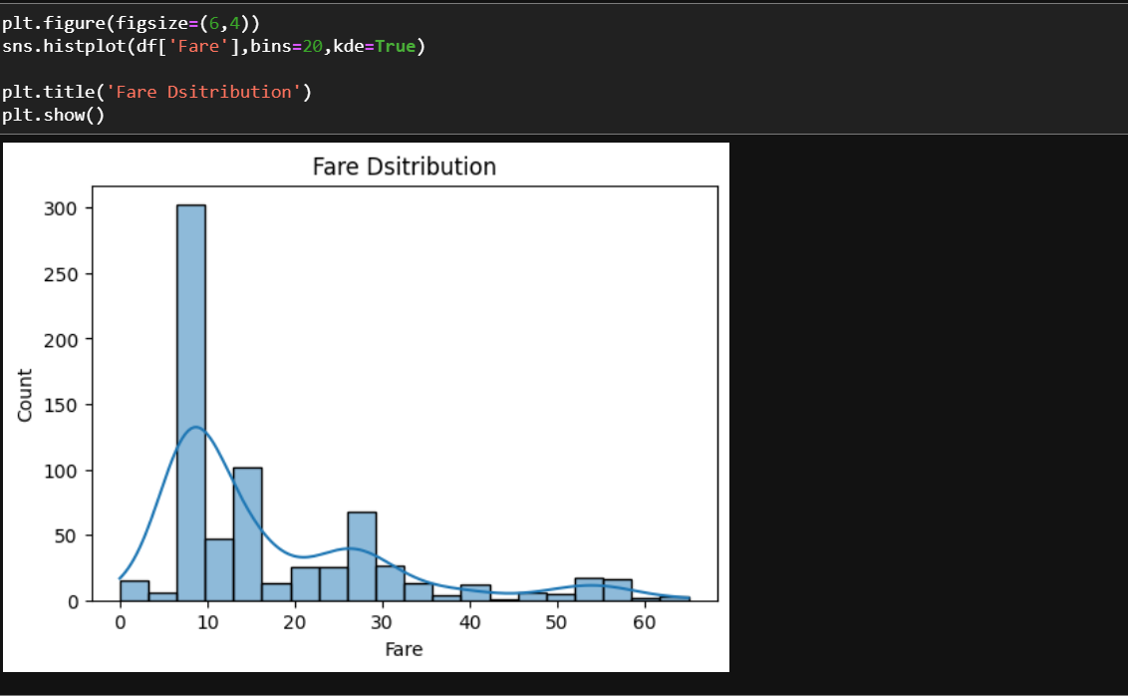 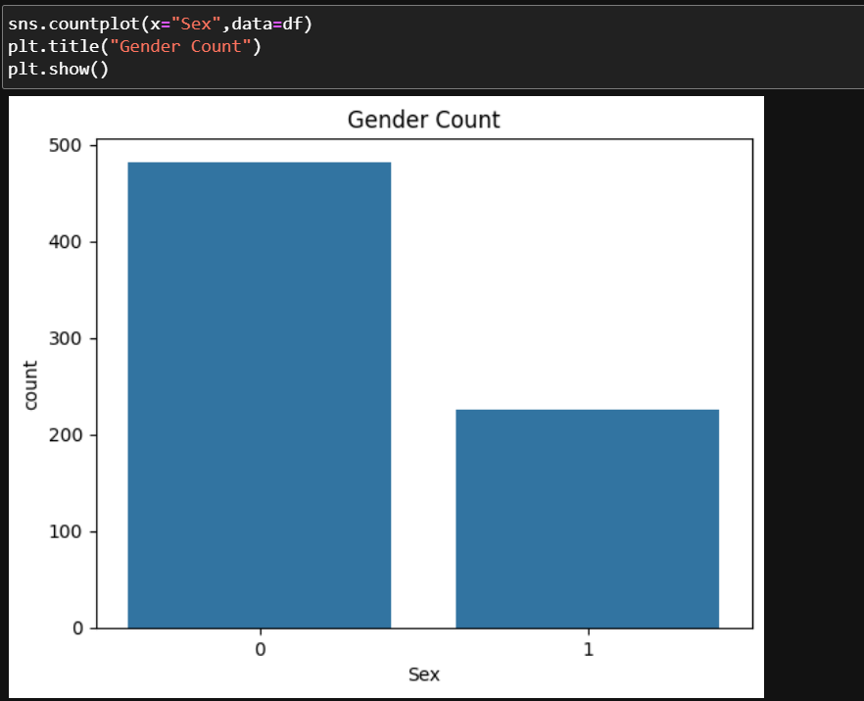
This command prints how many passangers are their in each category, the males are more then females are number of 0 is more than number of 1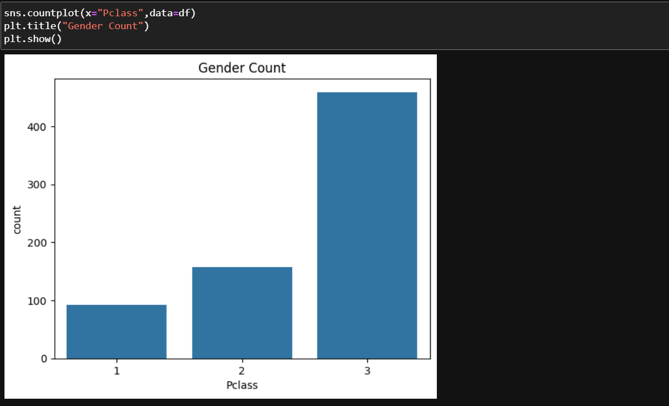
This command counts the passangers from each class , class 3 has max passangers while class 1 has lowest
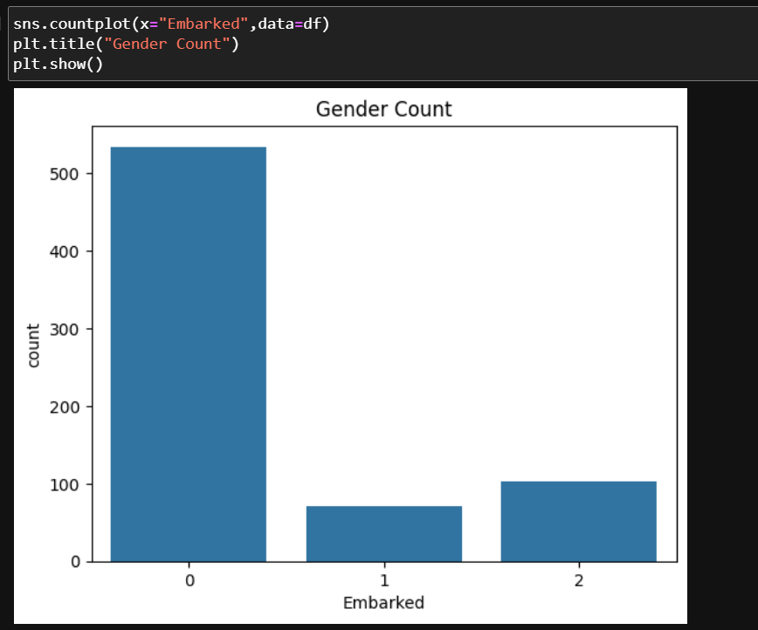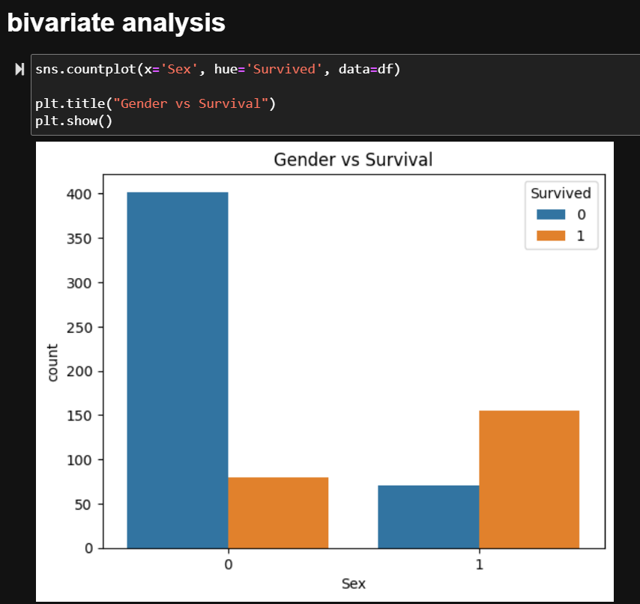
Bivariate analysis is analzing data on the basis of two varialbes . this command analysis the gender vs survival that which gender survived more 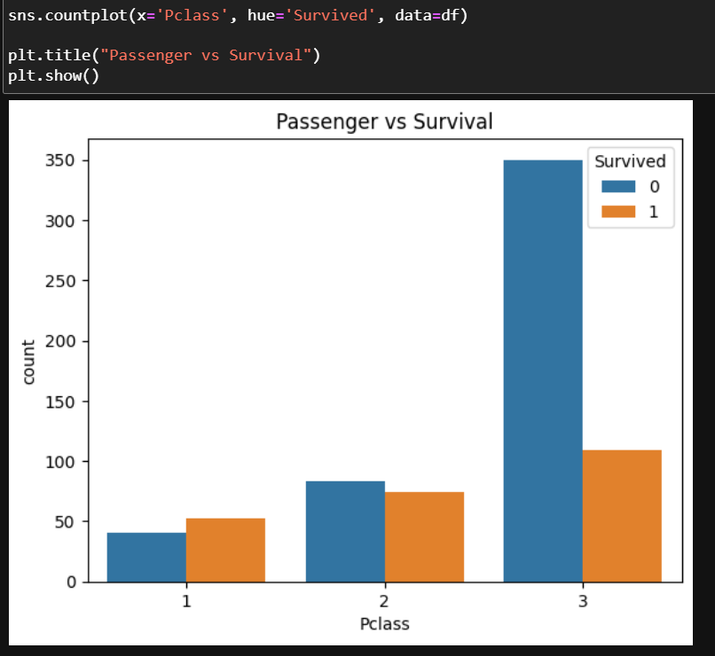 this command analyzes which gender from which class survives
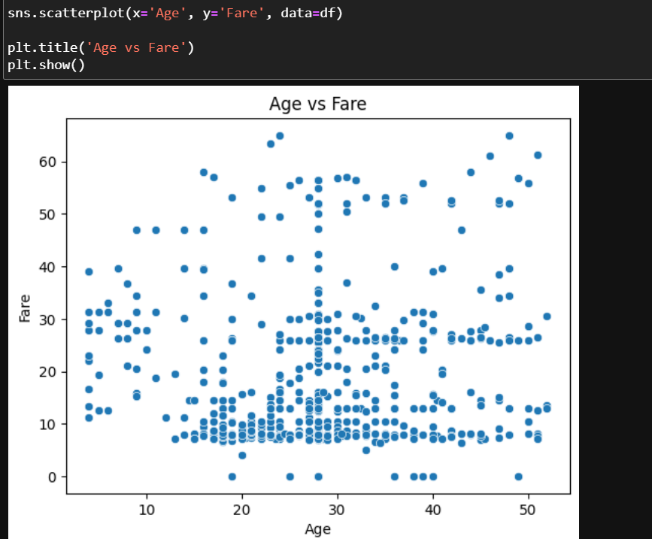 this command draws a scatterplot between age and fare, this helps to analyze which age group had bought what price of ticket 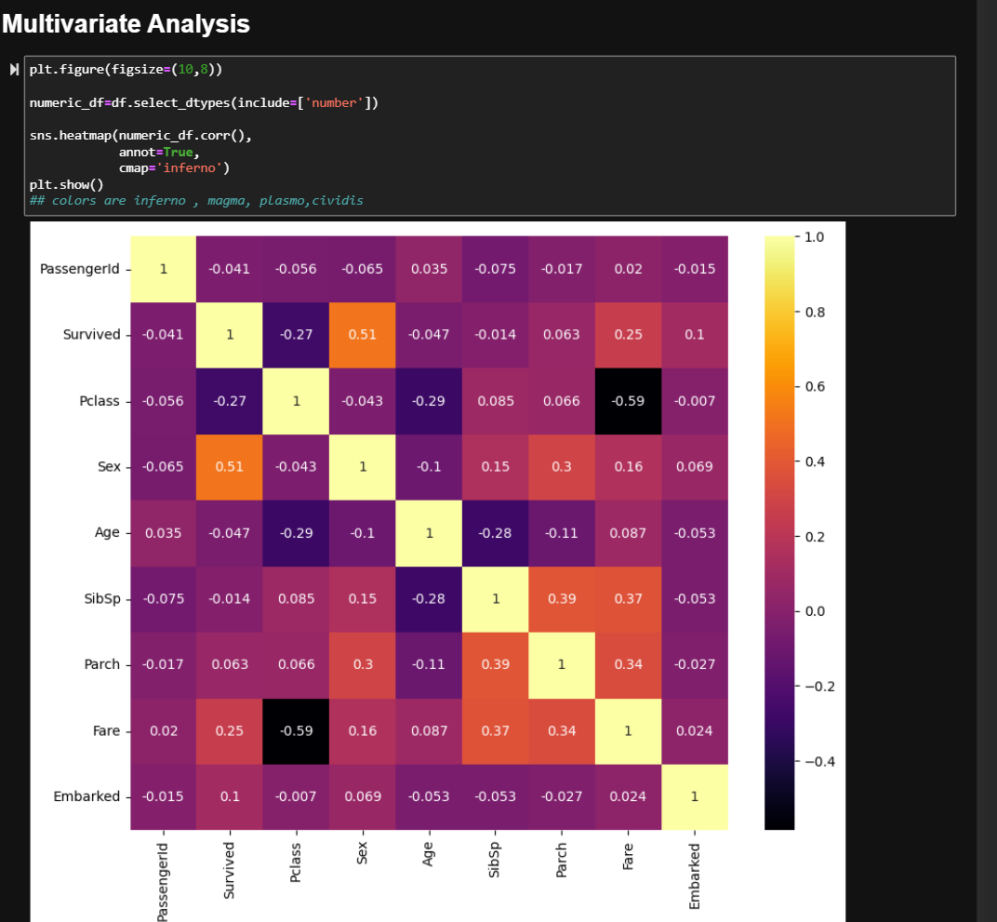 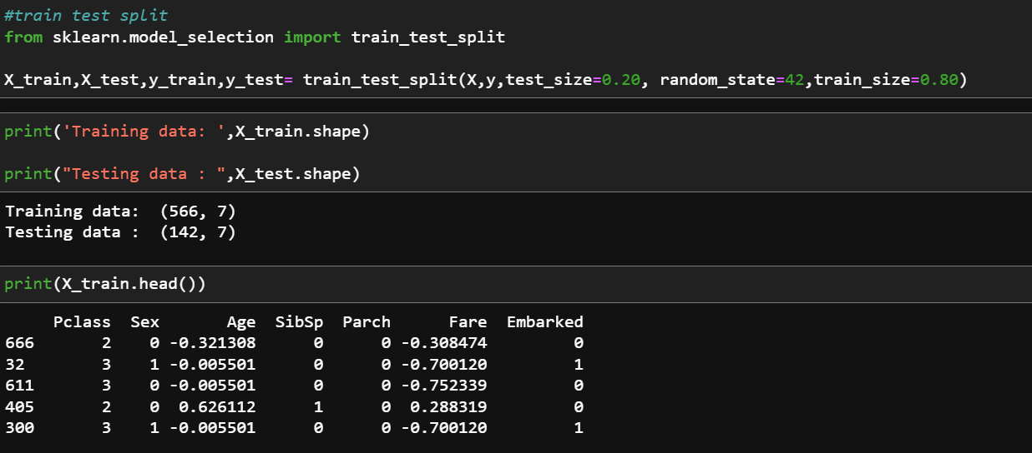
This comamnd divides dataset into training and testing data, split into 80% testing and 20% testing and random_state=42 is used to define the randomness , this numbers gives most appropriate output .

VIVA QUESTIONS:
1. What is StandardScaler()?
It is used for standard scaling.
It makes the mean 0 and standard deviation 1.
2. What is train_test_split()?
It divides data into training and testing data.
Here, 80% is training and 20% is testing.
3. Why do we use X.drop()?
It removes unwanted columns like PassengerId, Name and Ticket.
This leaves only the required features.
4. What is X.head(15) used for?
It shows the first 15 rows of the dataset.
It helps us check the processed data.
5. Why do we use random_state=42?
It fixes the random splitting of data.
So we get the same result every time.

